**NAME: AHSAN SAJJAD**

**ENROLLMENT: 02-131212-049**

**BSE-4B**

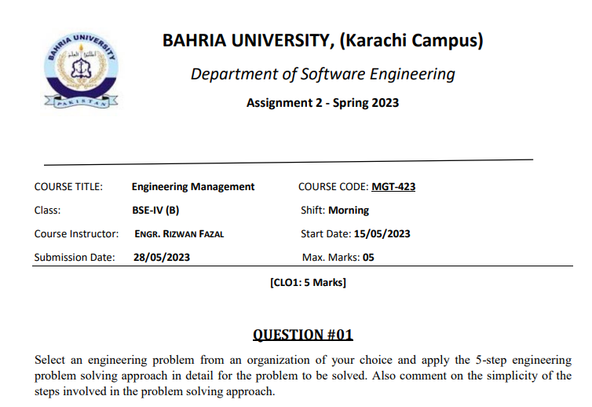

**Answer**

Whatever your line of work, it's nearly certain that an issue will arise at some point. If the issue isn't addressed right away with appropriate action, it can develop worse. Knowing how to resolve a problem effectively is essential because no one wants to work in a hostile environment. Any person who engages in the problem-solving process must possess a certain set of talents. These abilities include the capacity for study and the capacity for decision-making that involves both emotional intelligence and rationality. Another ability that is essential for making a successful business decision is risk management. Each member of your team should be able to collaborate with one another while solving problems. It's likely that yourTeam building. An Employee should have these abilities

* Brainstorming
* Active listening
* Creativity
* Analysis
* Good communication

Following are five step engineering problem solving approach explained with examples.

***Step.1****-* ***Define the problem.***

Finding the source of the issue is the first step in solving a problem, as apparent as it may sound. Unfortunately, finding the root of the issue sometimes involves additional investigation. Toyota's "Five Whys" strategy is one technique applied in this step**. Ask yourself the five whys in the event of a problem: Who, What, When, Why, and Where.** You can determine the precise source of the issue by asking yourself these questions in relation to it. There are three steps you can take to more accurately identify a problem if that is insufficient.

* Examine the circumstance: To try to understand the issue, elaborate on it. Try to put yourself in the other person's shoes if that person is the root of the issue.
* Come up with a problem statement: Put the issue on paper in the most basic terms possible.
* Do your best to respond to the inquiry, "Why is this current situation a problem?"You'll be able to better examine the situation once you've narrowed it down to one source.

***Step.2- Collect and analyze the getting data.***

The next step is to collect, analyze and create a list of possible solutions to the problem you’ve discovered. There are many ways to generate solutions. Brainstorming is the first way to think of a potential answer. This can be done individually or in a group setting. The latter is recommended, because the more input, the better, simply because different perspectives can lead to different solutions. There are more models for this situation that can help you create solutions, including:

**Means-End Analysis:** An artificial intelligence analysis that considers the ultimate objective and identifies the most effective method for achieving that objective.

**Plan Do Study Act Model is another name for the PDSA model.** This is a condensed form of the problem-solving approach, in which you begin by planning, test the theory, analyse the findings, then take action in response to observations. This procedure is repeated numerous times.

**Root Cause Analysis** - This technique is used to identify the underlying cause of the issue. To identify the root cause, follow these four steps. Determine the issue, develop a timeline, separate root causes from other elements, and produce a cause graph.

**Lean Prioritisation Method:** This method uses a two by two matrix with a scale from low to high on the X and Y axes. The Y-axis is labelled with value, and the X-axis is marked with effort. Label the four squares in the two by two grid with quick winners, big bets, maybes, and time sinks. To determine where to spend your attention, evaluate every issue and circumstance and classify them according to their appropriateness.

***Step.3- Search for optimal solutions.***

After a list of potential answers has been created, it's time to exercise your decision-making abilities. Analyse each potential solution and choose the one that works best for your current situation to find the best answer to the problem. Before selecting a remedy, one may want to take into account a number of factors. Effectiveness, applicability, timeliness, resources, and cost are some of these factors. Before making any judgements, remember to take into account all parties. Elimination is yet another effective method for reducing your options. Risk management will also be employed to assist in this decision-making. Similar to brainstorming, selecting a solution need not be done alone.

***Step.4- Evaluate alternatives.***

Once an alternative has been determined, it is time to assess it by weighing its advantages and disadvantages for the organisation. Planning, perseverance, and patience are all needed to implement a new shift in any firm.

**Planning** – Recognise that timing is crucial, and that it frequently takes a lot of time for a company to implement a new strategy. Set definite objectives, deal with any problems or potential impediments, and develop a plan. Additionally, it's critical to have effective communication skills throughout the entire organisation so that everyone is aware of the expectations.

**Patience** – Change can be frightening, and not everyone is always open to the notion, so it's crucial to exercise patience throughout this process. To avoid overwhelming the staff, try rolling out the plan gradually. Encourage one another and make certain that everyone is aware of the change's purpose and is actively working to achieve it.

**Persistence** - Last but not least, it's critical to keep these changes under constant application and observation. Every week, you as an employer must ensure that all of your staff members are putting the changes into practise. Only then can outdated behaviours be forgotten. You may have another issue on your hands if an employee is inconsistent.

***Step.5- Select solution and evaluate the impact.***

The application of the solution and analysis of the outcomes constitute the final step in the problem-solving process. Depending on what you are trying to change or accomplish, this can be done a few weeks, months, or years after the initial action. It's critical to keep in mind how the issue affected the business and why it arose in the first place. To more accurately assess outcomes, ask yourself any of the questions listed below:

* Is the preceding issue interfering with any of our processes?
* Will any new issues surface now that the procedure has started?
* Is there a chance the problem might come up again?
* Is everyone aware of the initial issue, the proposed remedy, and the rationale behind it?
* Do you need to change any policy, procedure, or personnel to avoid this from happening again?

It is occasionally essential to restart the procedure from scratch. It's best to simplify the solution as much as possible in order to facilitate the problem-solving process. Try to keep your attention on the solution rather than the issue. Finally, adopt the proper mindset if you want to change. This includes speaking with the proper attitude and being open-minded and cheerful. Any issue may be resolved with enough practise.